AKSHAYA S
EXP 4 Shortest Job First (SJF) Scheduling — Smallest Execution Time
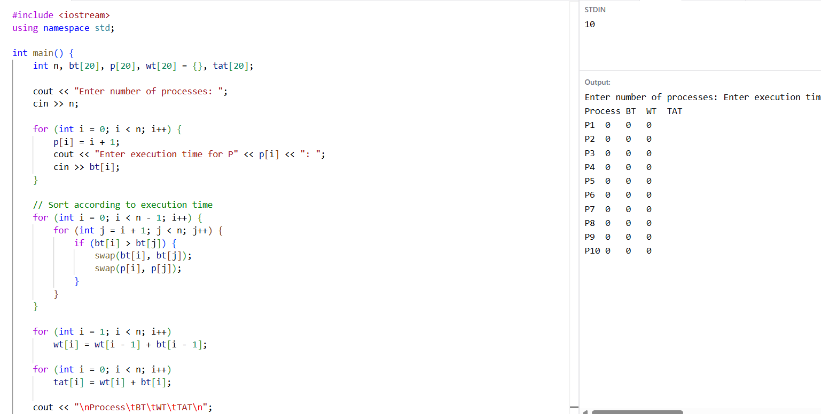
EXP 5 Non-Preemptive Priority Scheduling — Highest Priority First
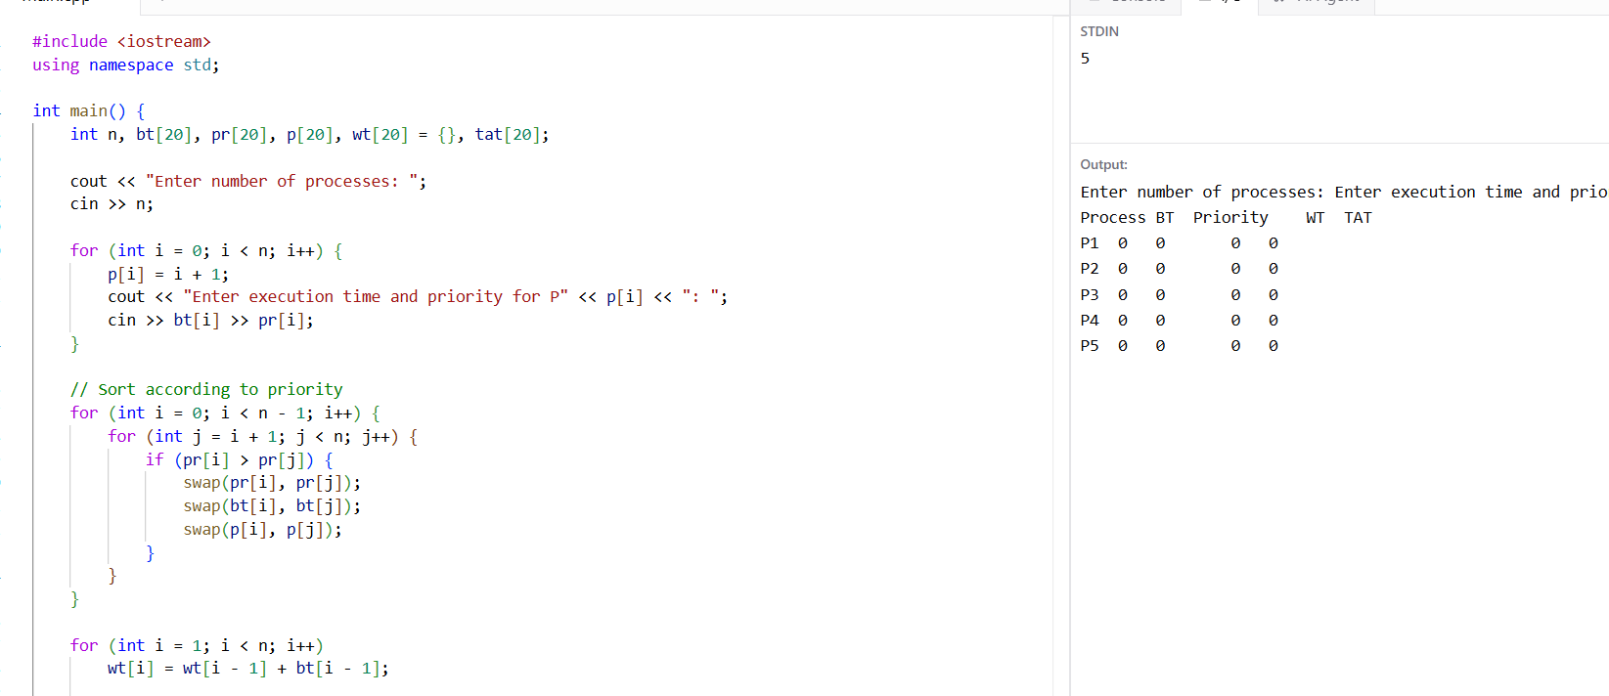

EXP 6 Pre-emptive Priority Scheduling
